CPT 401 is a Senior Project Course
The Senior Project is a student-selected exploration of a topic which results in a research paper, a project or a product, and a presentation. The Senior Project moves students away from departmentalized learning toward a more interdisciplinary approach. This approach is one which allows students to use a variety of skills in the areas of writing, speaking, research, and documentation.
Student Project Guidelines
Students will complete a complete life cycle project:
- Project description
- Design
- Gantt Chart: Project and personnel resources to complete project: Free Gantt Chart Template for PowerPoint (Links to an external site.)
- Project work
- Analysis of completed project successes/Failures
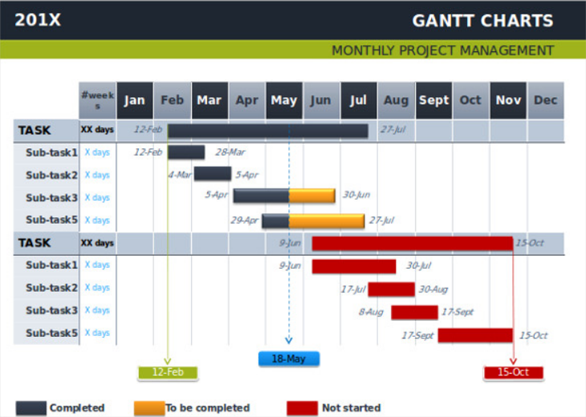

Deliverables:
(each part below will take approximately 2 weeks)

Part 1: Enter Project description (by end of first two weeks of the semester)

Part 2: Enter a Project Design Document

Part 3: Create a preliminary Gantt Chart

Part 4A: First Part of Project Design

Part 4B: Second Part of Project Design

Part 4C: Final Part of Project Design

Project Presentations Last Two Weeks of Semester

The Software Specification Design Documents
So, when you take on a new project, before you even open Xcode or Visual Studio, you need to have clear and agreed-upon design goals. And these goals should be established in a specification document. If the client hasn’t written one, you should write it, and submit it to them for review before you even open your IDE. And if you encounter a client who says, “We don’t have time for design documents”, candidly, you should walk away from the project because you have trouble ahead. The specification need not be particularly lengthy; it can be just a few pages, but at the very least it should lay out the user interface, include wireframes (if there’s a UI component), and set completion milestones.

Grading:
Each of the six parts of the project, listed above will be submitted on Moodle
approximately every two weeks.
Documentation (75 pts)
Part 1 (15pts)
Part2 (15 pts)
Part 3 (15pts)
Part 4a (10pts)
Part 4b (10pts)
Parts 4c(10pts)
Final presentation 25 pts

